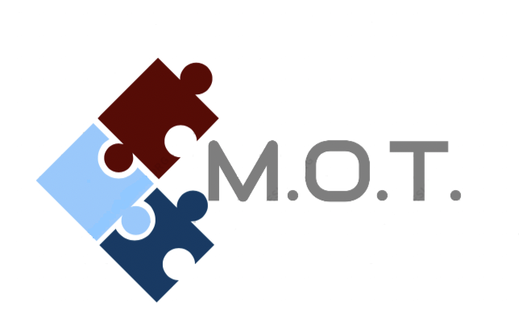
Greetings,
Men of Today, L3C is a nonprofit organization with the objective to instill work ethics amongst our youth by creating an economic opportunity for individuals and organizations within the community by selling positive paraphernalia through M.O.T.’s “The Good News” t-shirt fundraiser. Replacing ideal time with entrepreneurial activities, adolescents will have an opportunity to practice and enhance skills in customer service, networking, and business communication with the intent to effect unemployment rates within the community for the long term.

The Goal of the program is to sell 1,600 T-shirts to sponsor "The Blackout" Event, a black-owned business networking event for the community. Our mission, at minimum, is to locate sixteen young entrepreneurs and sixteen organizations to voluntarily participate with the fundraiser.

For every ten shirts sold, individual/s or organization/s will receive $50 payouts which will increase with sells. Provided below is a possible payout chart to illustrate increases:

Individual Entrepreneurship Program Organizations fundraisers
10 - 19 = $50 100 - 199 = $500
20 - 29 = $100 200 - 299 = $1,000
30 - 39 = $150 300 - 399 = $1,500
40 - 49 = $200 400 - 499 = $2,000
50 – 59 = $250 500 – 599 = $2,500
100 = $500 1,000 = $5,000

Individuals/organizations may also receive additional payouts from referrals. For every 5 individual referrals, $50 payouts will be received once those referrals’ order forms are turned in. For every organizational referral, the referrer will receive half of what the organizations payout amount is once order forms are turned in. Occasionally, M.O.T. will pay $2 per shirt sold in addition to all other payouts.

Each selling package includes selling envelope, informative letter, selling brochure, and volunteering participant’s consent form. Products consist of four categories of T-shirts: Good News T-shirts (Inspirational shirts), Marriage T-shirts, Black Legends T-shirts (Custom black generational legends), and Children T-shirts (which includes Onesies). All regular size shirts are $20 (sizes larger than 2x are an additional $10) and all children products are $15. Children sizes range from 0-3 months, 6-9 months, 12 months, 18 months, 2T-5T, and youth sizes small, medium, and large. Adult V-neck shirts are also available for $25. Shipping and handling are optional with an additional $5 charge. All orders requiring S&H and Black Legends orders, should be placed on the selling envelope. All other orders can be placed either on the brochure or selling envelope.

Volunteering Participant’s Consent Forms and “The Good News” order forms may be downloaded on www.motnonprofit.com and uploaded/sent via email motnonprofit@gmail.com. Products can be shipped directly to customers with an additional $5 S&H fee or free of charge to volunteering participant’s address. Money for orders and payouts can be turned in/received on www.motnonprofit.com as well. If not received or submitted electronically, order forms and product pickups, order form drop-offs, and all payouts will occur ONLY on Sundays between 4-5 p.m. at designated locations and dates which are posted on www.Motnonprofit.com. Thank you for your interest in MOT’s “The Good News” Fundraiser and we can’t wait to partner with you.

Kennith D Tolliver, The Good News Director
(255) 964-7414
www.motnonprofit.com
MOTnonprofit@gmail.com

