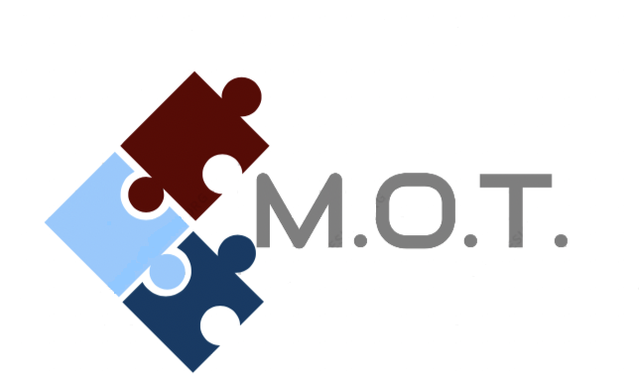
Volunteering Participant’s Consent Form

Thank you for your interest in MOT’s “The Good News” Fundraiser. Before the selling of any “Good News” products may begin, each volunteering participant must turn in this Volunteering Participant Consent Form, either in person or electronically to Men of Today, L3C. Once consent form is received, a confirming email will be sent out and your name will be placed on www.motnonprofit.com as a volunteering participant and only then will participants be allowed to start selling products. Volunteering participants are responsible for all money collected until turned over to Men of Today, L3C and have received an official receipt from the nonprofit for the amount turned in.
Volunteering Participant’s Consent Forms and “The Good News” order forms may be downloaded on www.motnonprofit.com and uploaded/sent via email motnonprofit@gmail.com. Products can be shipped directly to customers with an additional $5 S&H fee or free of charge to volunteering participant’s address. Money for orders and payouts can be turned in/received on www.motnonprofit.com as well.
If not received or submitted electronically, order forms and product pickups, order form drop-offs, and all payouts will occur ONLY on Sundays between 4-5 p.m. at designated locations and dates which are posted on www.Motnonprofit.com. Thank you for your interest in MOT’s “The Good News” Fundraiser and we can’t wait to partner with you.

_____________
Date

___________________________________ ________________ __________________________
Volunteering Participant’s Name Contact # Email Address

_________________________________________
Volunteering Participant’s Signature

_________________________________________
Volunteer Participant’s Legal Guardian’s Signature

Kennith D Tolliver, The Good News Director
(255) 964-7414
www.motnonprofit.com
MOTnonprofit@gmail.com

